Introduction to Version Control

Question 1)

Git Setup <https://confluence.atlassian.com/bitbucket/set-up-git-744723531.html>



Question 2)

Initialize a Git Repository

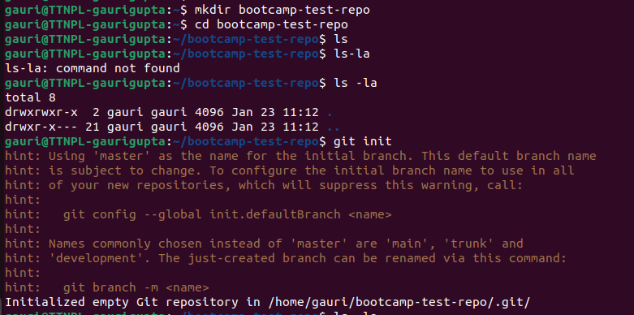

Question3)

Add files to the repository

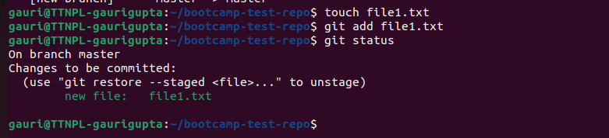

Question4)

Unstage 1 file

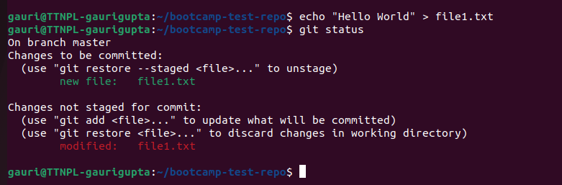

Question 5)

Commit the file

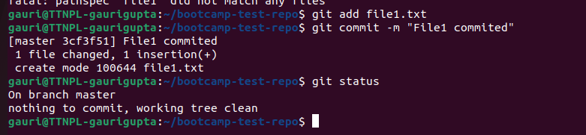

Question6)

Add a remote



Question7)

Undo changes to a particular file

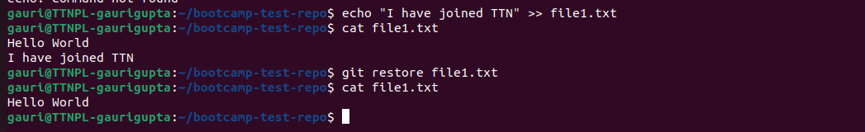

Question 8)

Push changes to Github

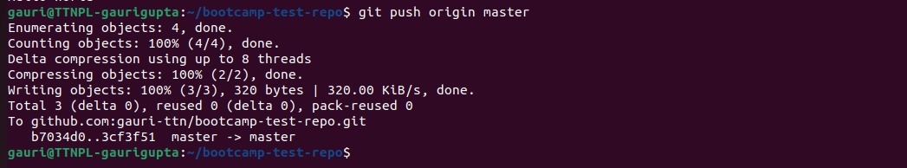

Question9)

Clone the repository

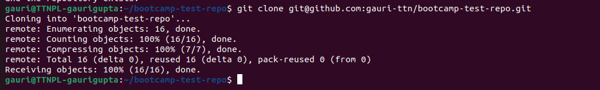

Question 10)

Add changes to one of the copies and pull the changes in the other.

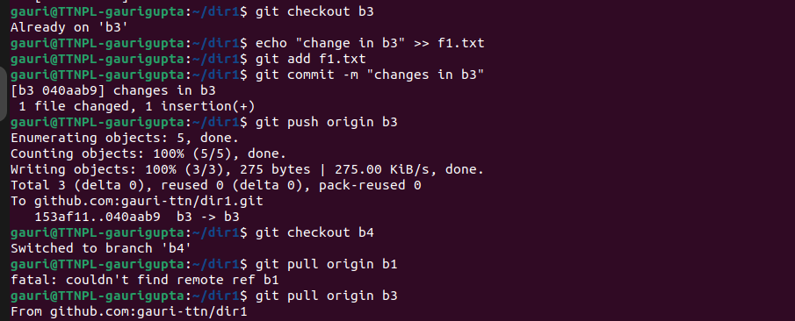

Question11)

Check differences between a file and its staged version

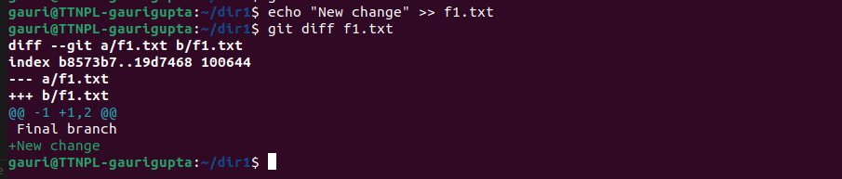

Question12)

Ignore a few files to be checked in



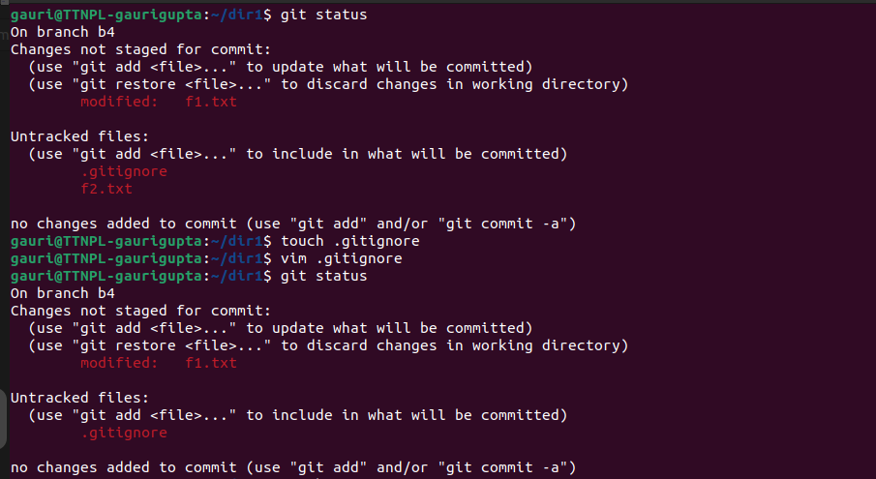

Question13)

Create a new branch



Question14)

Diverge them with commits

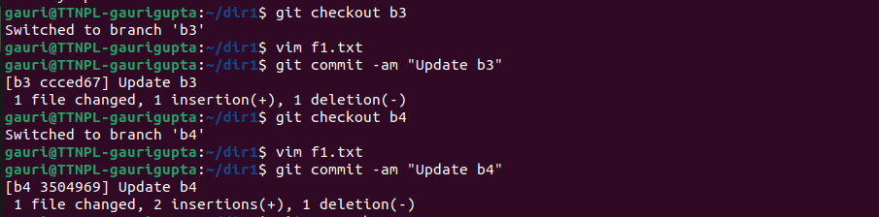

Question15)

Edit the same file at the same line on both branches and commit

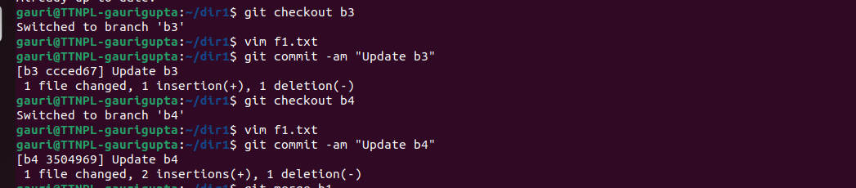

Question16)

Try merging and resolve merge conflicts

a) After merging , conflicts has rised.

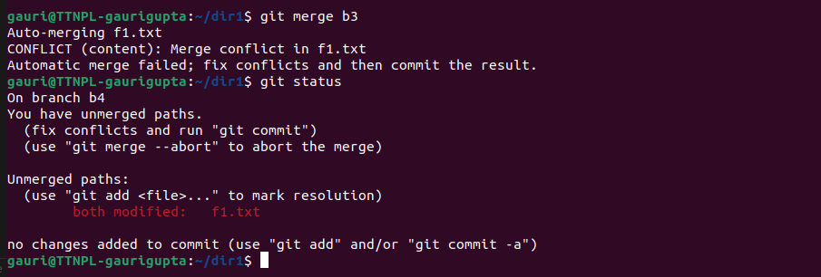

b)In f1.txt it is showing , about conflict.

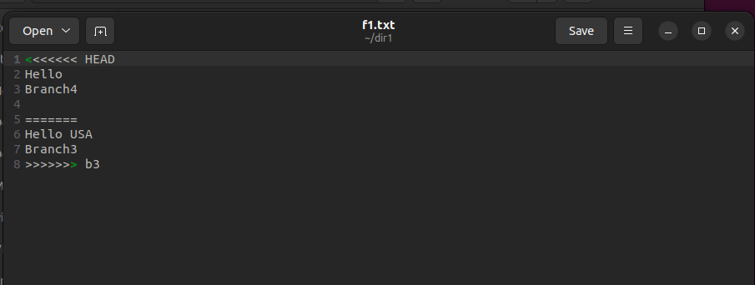

c)To resolve the conflict , we selected the final line.



d) After resolving the conflict.



Question17)

Stash the changes and pop them

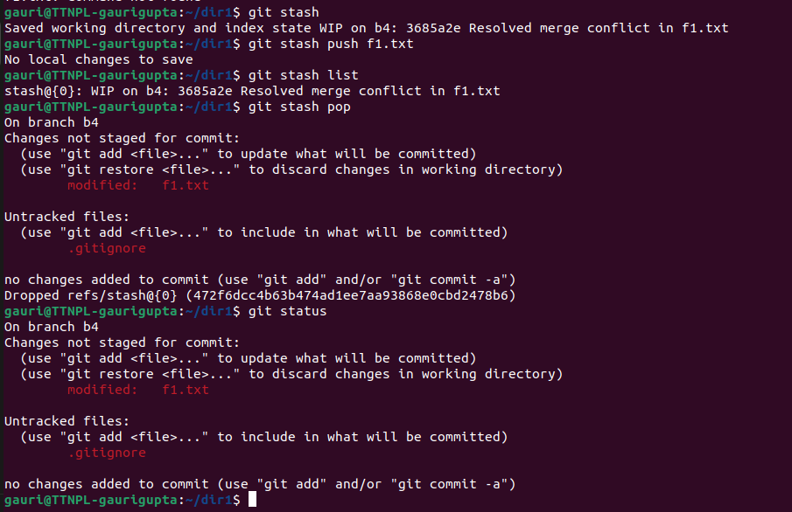

Question18)

Add the following code to your .bashrc file : color_prompt="yes" parse_git_branch() { git branch 2> /dev/null | sed -e '/^[^*]/d' -e 's/* \(.*\)/(\1)/' } if [ "$color_prompt" = yes ]; then PS1='\u@\h\[\033[00m\]:\[\033[01;34m\]\W\[\033[01;31m\] $(parse_git_branch)\[\033[00m\]\$ ' else PS1='\u@\h:\W $(parse_git_branch)\$ ' fi unset color_prompt force_color_prompt

